Design Specification Document

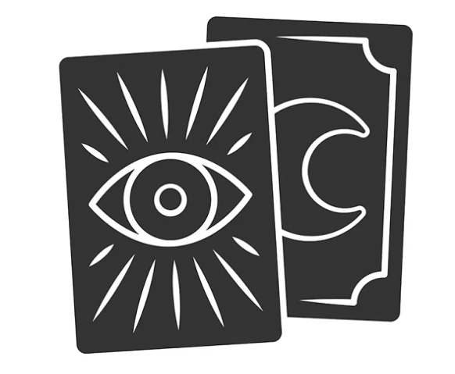Tarot Reading App

v 1.0

by Anna Garmiza

**Introduction**

Tarot Reading Web App – A digital tarot reading system. The tarot provides a glimpse into our inner self world. The cards reflect our thoughts, emotions and help us to truly connect and understand ourselves.

**Terminology**

Card spread

spread layout

**Use Cases**

Main Functionality:

The interface allows the user to select the desired card spread. Next, allows the user to shuffle the deck and type in an open ended question to ask the cards. Finally, the user will choose from facedown cards. The system will place the cards according to the spread layout and will return to the user a complete card interpretation based on card selection.

The interpretation varies based on card meanings, type of card opening, combination of cards (certain rules), user’s question.

In addition to the main functionality:

* Reading user’s card spread according to submitted question. A user will submit a question for getting adjusted interpretation (e.g. love, career, wellbeing)
* User sign up + login.
* Reflection – an input field for the user to document feelings and thoughts that arise from the reading (for signed up user).
* Reading History – Saving user’s reading and the relevant reflection (for signed up user).

Optional:

* Mirroring – analysis of past user’s reading according to different criteria and showing a mirroring report (for signed up user).
* User management (for admin) – Updating card content, Getting users asked questions report (learning of recurring popular topics).
* Tailor maid reading interpretation – returning an adjusted reading (love, career, wellbeing). For example, if the question includes ‘money’ – a financial answer will be displayed.
* Feedback – collecting user feedback after a reading (liked/disliked) in order to improved the digital response.

**Architecture**



Server Side

App Logic

Node.js

USER

WEB – Client Side

Angular



Database

MongoDb

***INITIAL UML

